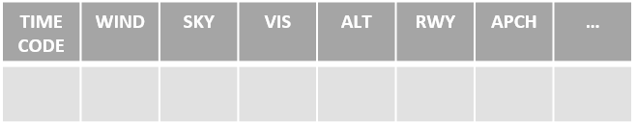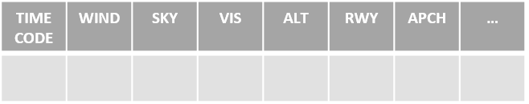

SEGMENT

ATIS

AIRPORT

ROUTE

GPS

Primary Comm

Secondary Comm

Primary Nav

Secondary Nav

Heading

ATIS

Review Appch Plate

DME

LOADED

ACTIVATED

CORRECT SOURCE

TOWER

NEXT FREQ

SET

TWIST

ID

SET

TWIST

ID

PRECES

BUG

OBTAIN

IAF/FAF

ALTS/DIST/FIX

MISSED

NOTAMS

SET

ID

PRIOR TO FAF

Power

Flaps

Gas Tank

Under Carriage

Mixture

Prop

SWITCHES

MISSED

Cram

Climb

Clean

Comm

SEGMENT

ATIS

AIRPORT

ROUTE

LOADED

ACTIVATED

CORRECT SOURCE

TOWER

NEXT FREQ

SET

TWIST

ID

SET

TWIST

ID

PRECES

BUG

OBTAIN

IAF/FAF

ALTS/DIST/FIX

MISSED

NOTAMS

SET

ID

PRIOR TO FAF

Power

Flaps

Gas Tank

Under Carriage

Mixture

Prop

SWITCHES

MISSED

Cram

Climb

Clean

Comm

GPS

Primary Comm

Secondary Comm

Primary Nav

Secondary Nav

Heading

ATIS

Review Appch Plate

DME